**❤REPRESENTED By AYESHA KHAN ❤**

**Andriod Install SetUp Step By Step**

**==**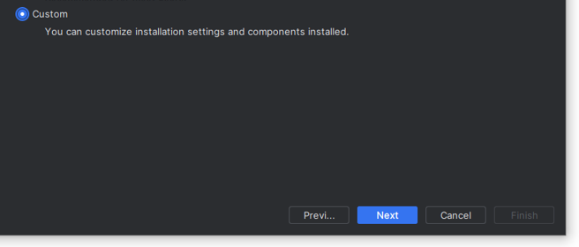

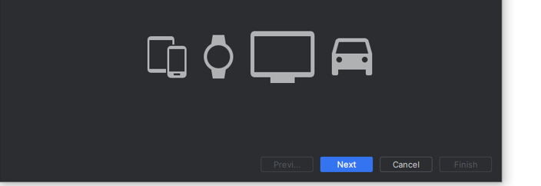

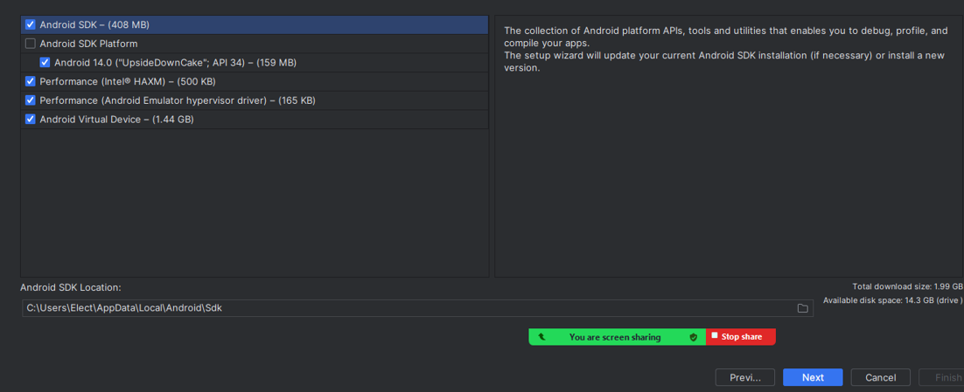

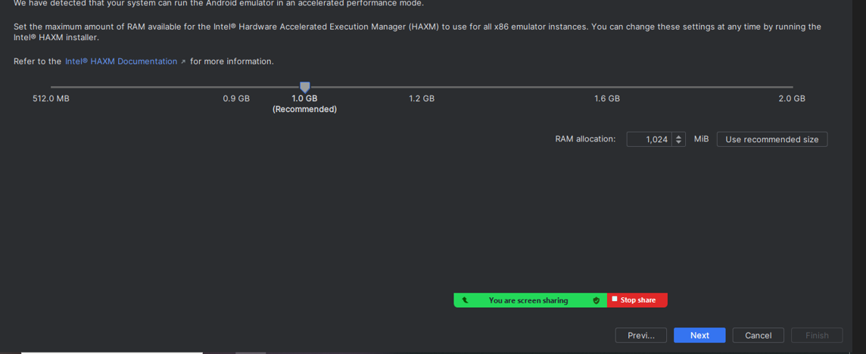

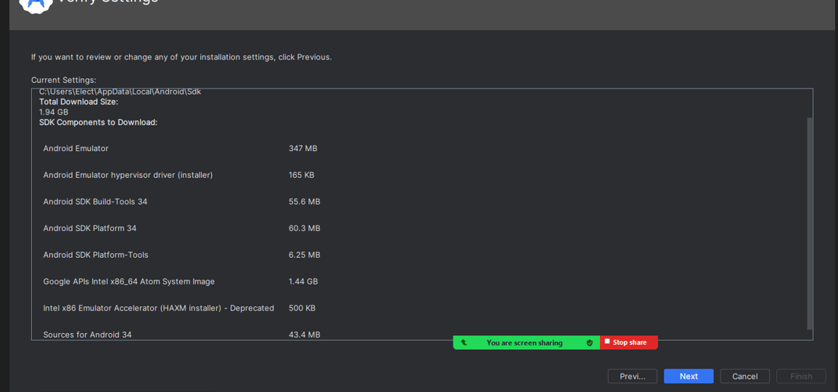

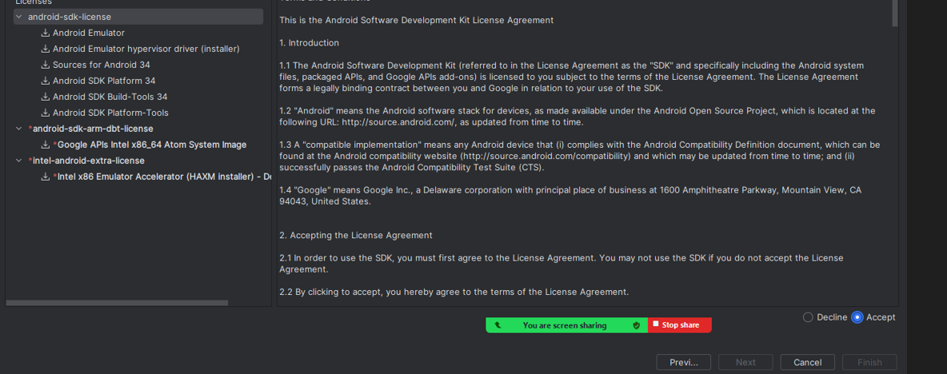

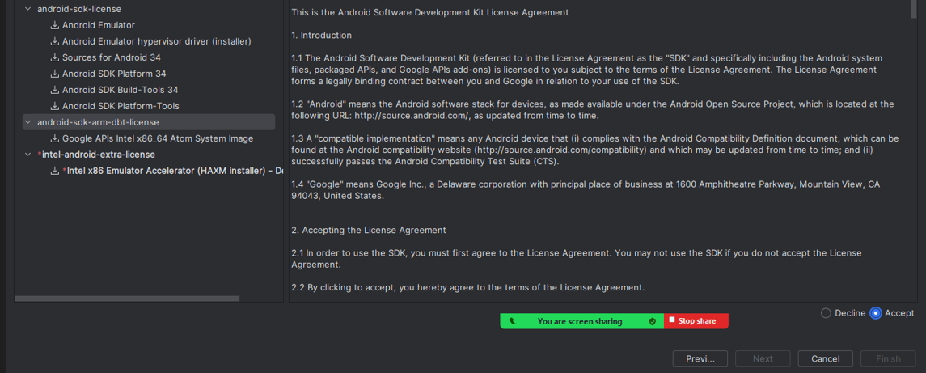

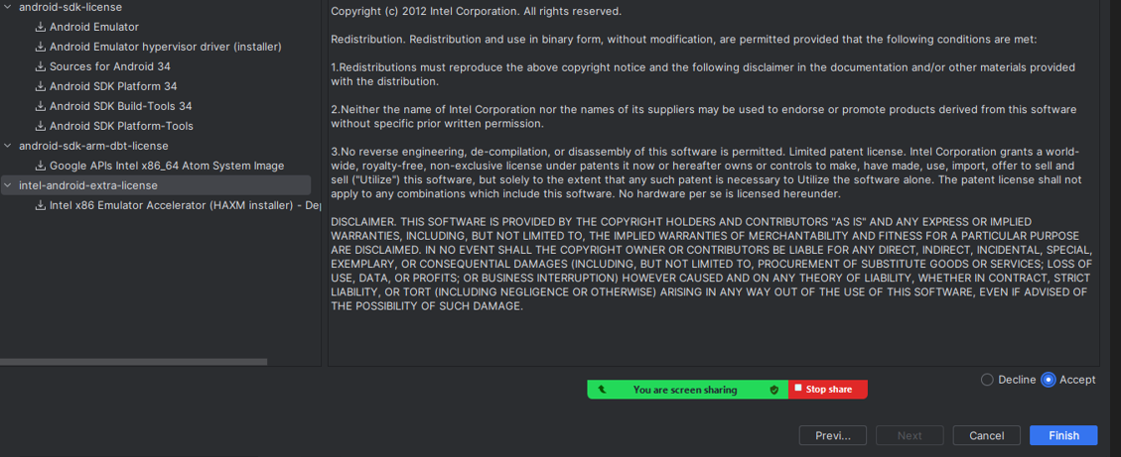

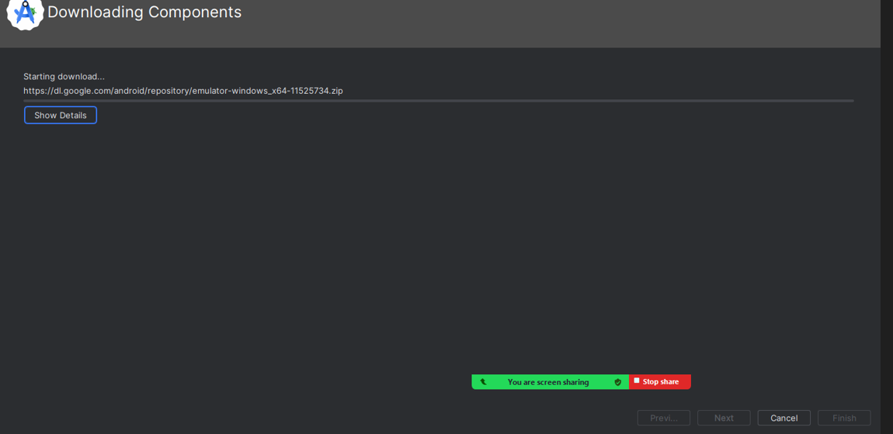

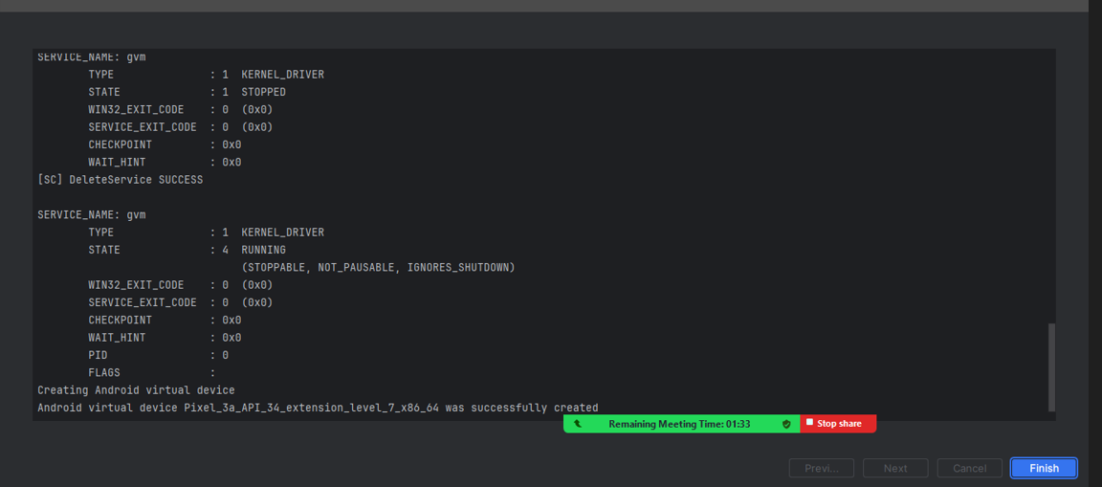

**Plugins Install**

**1.Flutter**

**2.Dart**

**3.Highlights Brackets Pairs**

**4.Andriod apk support and ndk must be checked**

[ Wasy all ready apk install hota hai agr na ho tu phir ham issy install krein gy otherwise nhi]

Open Andriod Studio Installation & Install Plugins

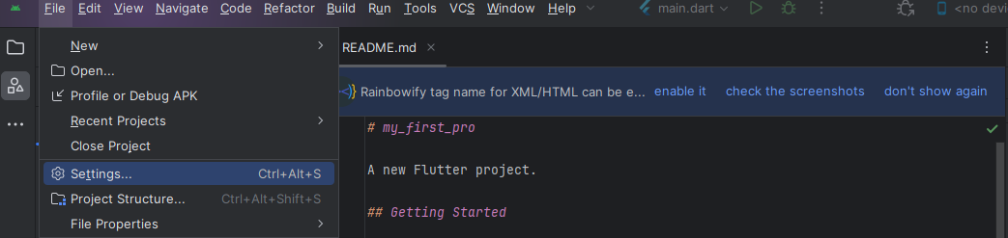

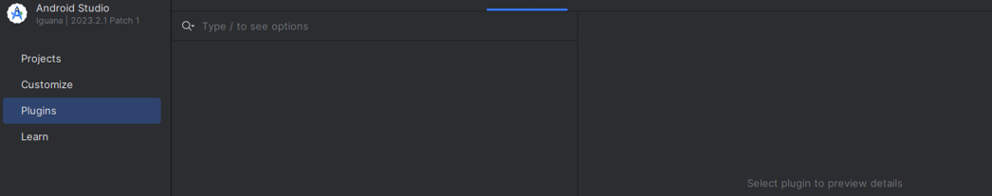

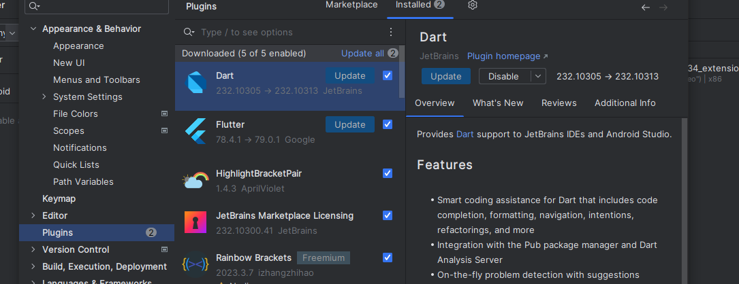

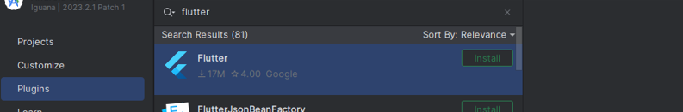

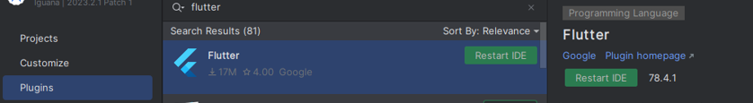

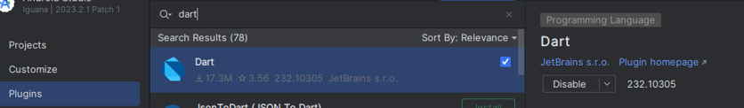

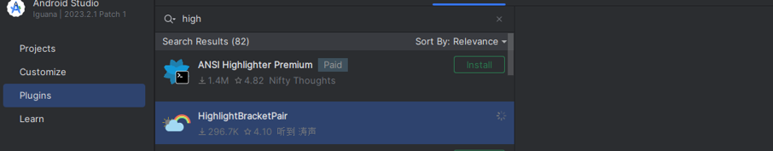

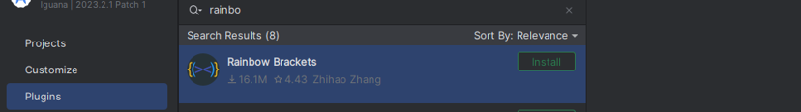

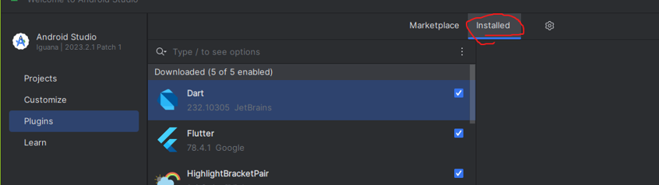

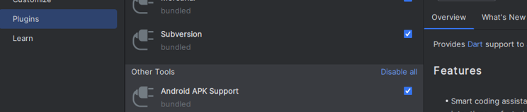

**CREATE PROJECT**

Select New Flutter Project

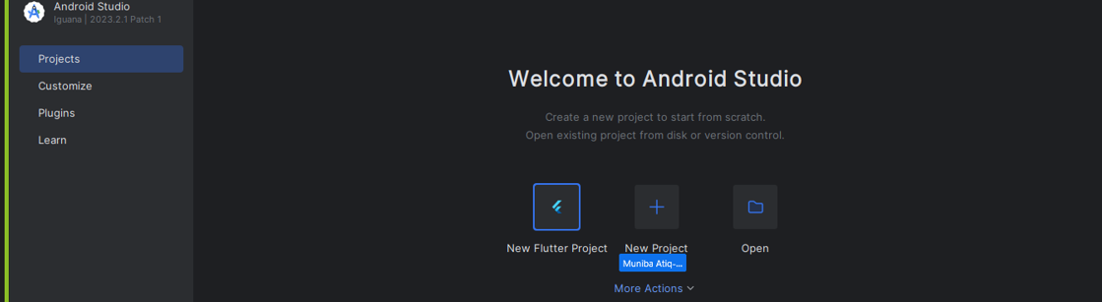

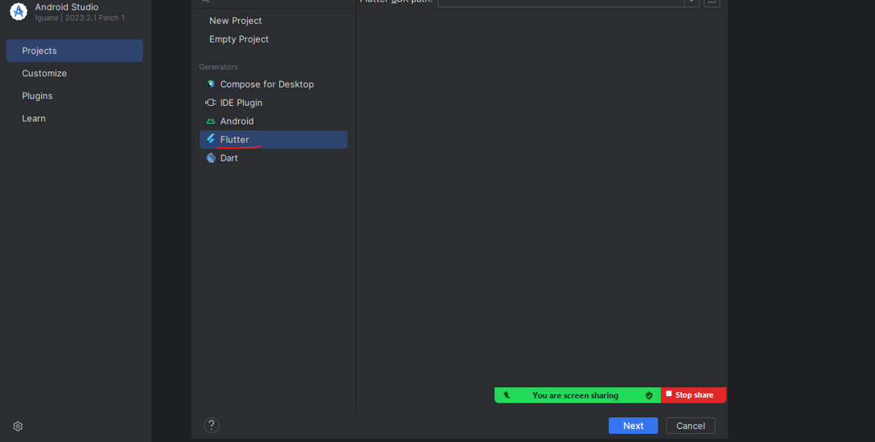

Open flutter folder and Select bin folder ,Copy Flutter SDK path

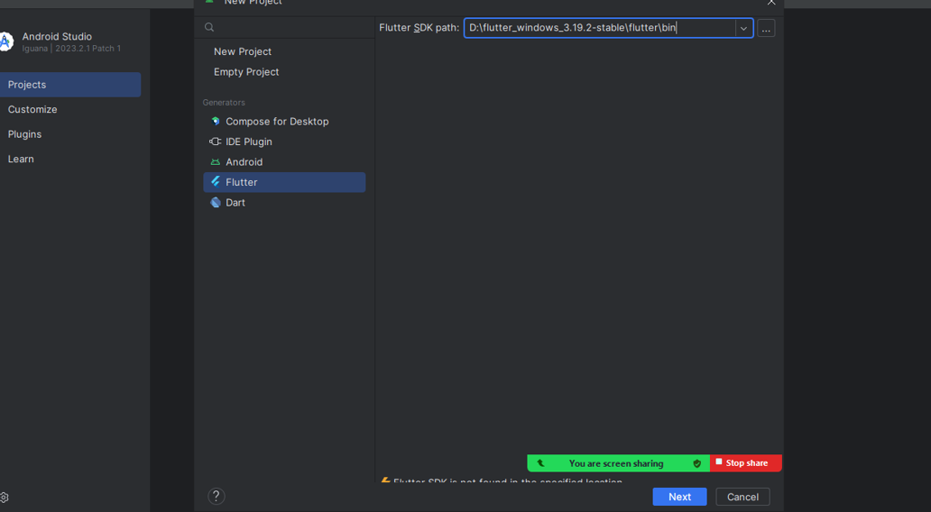

**Agr SDK Path Copy Paste krny k sy next nhi ho rha tu phir second option use krein gy**

**1_ Press window + I ToOo Open Setting**

**2_Select 🡺system option 🡺 Select About🡺Advance System Setting🡺**

**3_Click”Environment Variable”🡺Click edits🡺Click Ok and Window To save Change**

**4_Restart The Enviroment Variable Window To See The Update Value**

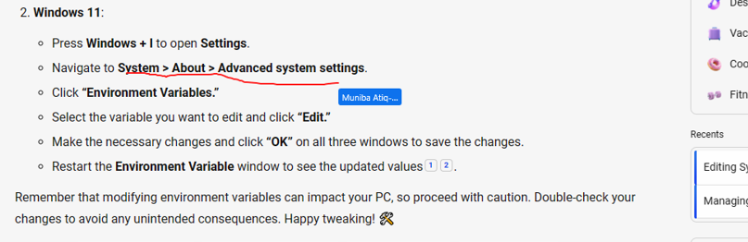

**CREATE NEW FOLDER AND OPEN VS CODE**

**Go To Extension Install Flutter and Dart**

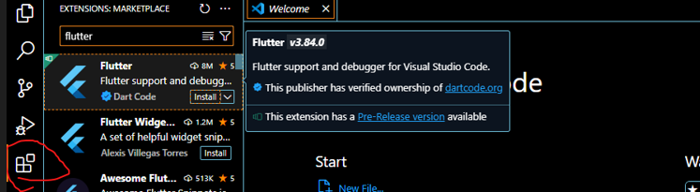

**Open terminal and Create new project**

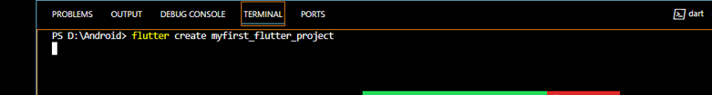

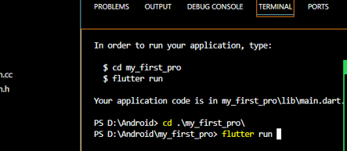

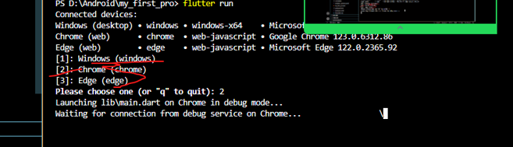

**Click No Device And Your Programme**

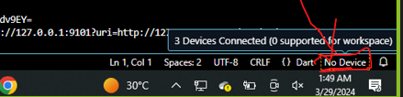



**---------Out Put----------**

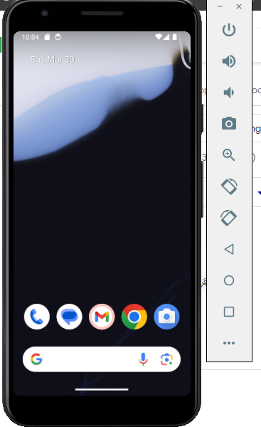

**❤Add Container && Text Button With Using Flutter❤**

**—1-- Center klye 🡺 Child Ka Use Krein Gy🡪 Jis Mai Ham Just One Container Ka Use Kr Skhty Hainn--**

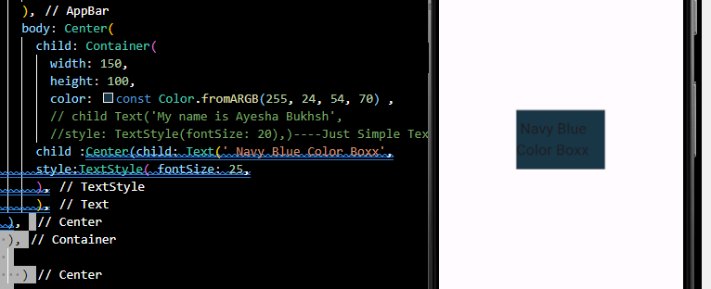

**--2 --Row Aur Coloumn klye Children kii Class Ka Use Krein gy 🡪Jis Mai Ham Multiple Coloumn ka Use kr Skhty hain--**

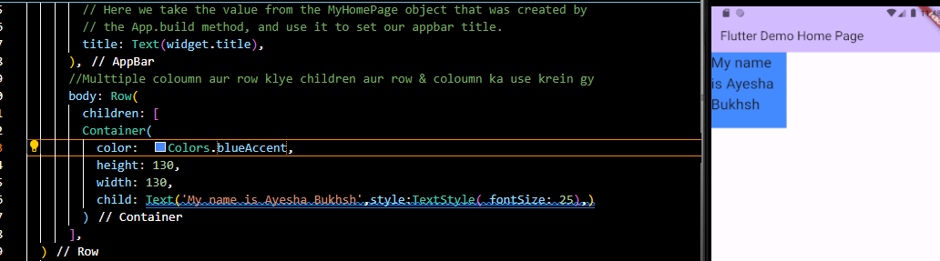

**==========RowS WithOut BackGround========**

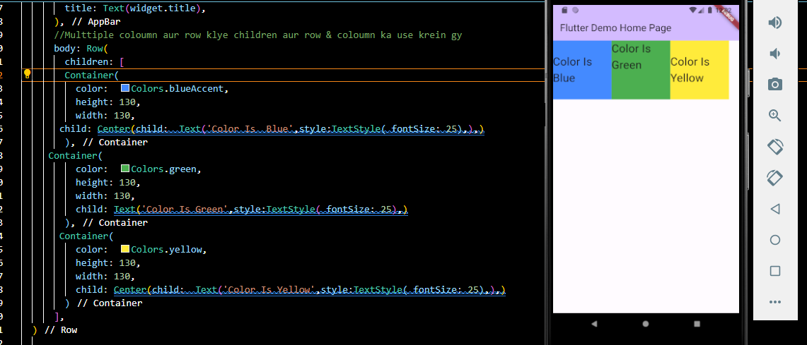

**----Step 2 With Background----**

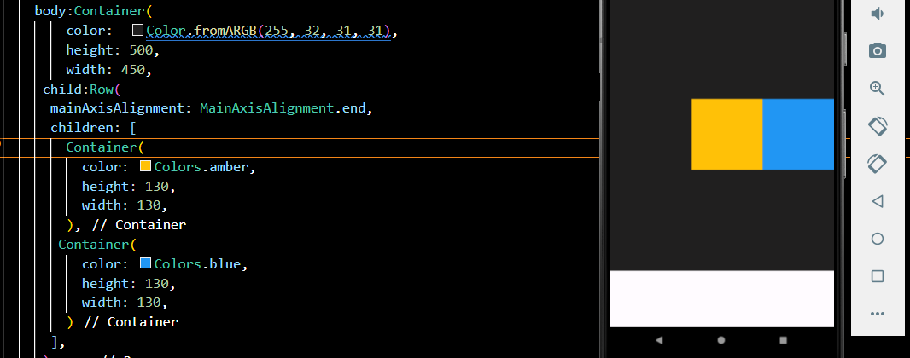

**======ColouMnS WithOut BackGround=====**

**s**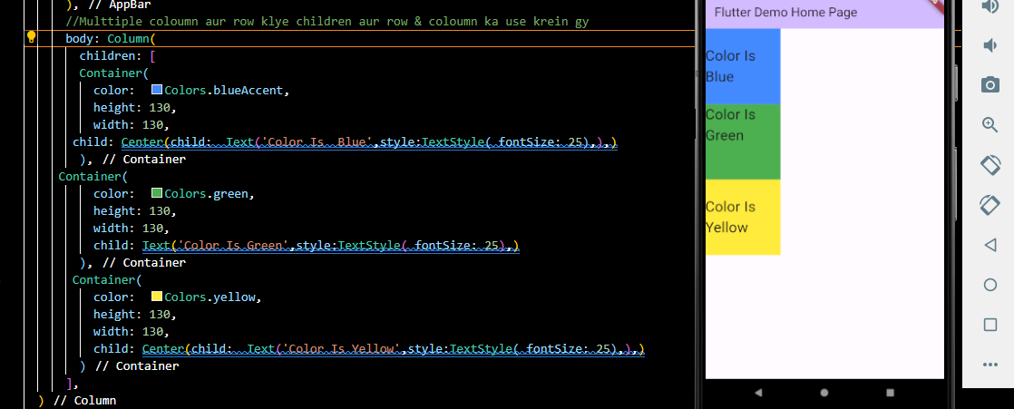

**====Spacing Container====**

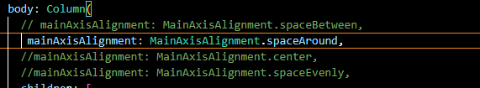

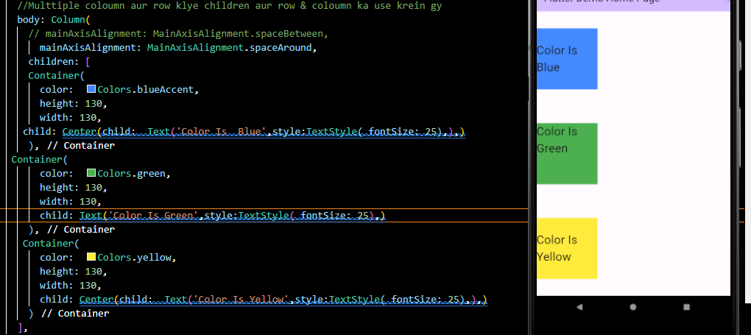

**======Add Buttons =======**

**TypeS Of Button=🡺.TextButton,OutlineButton,EveLatedButton**

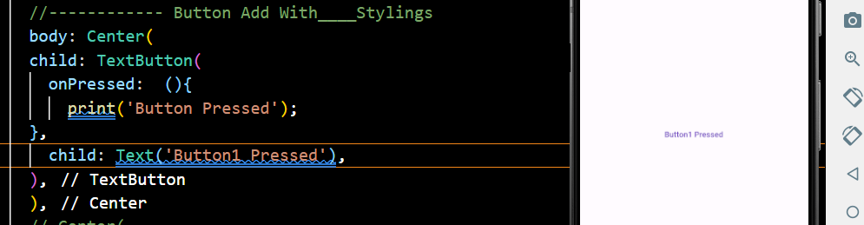

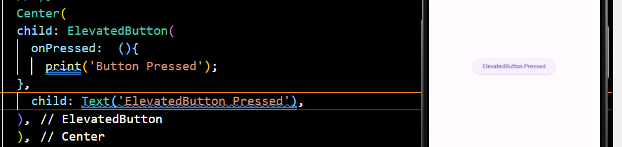

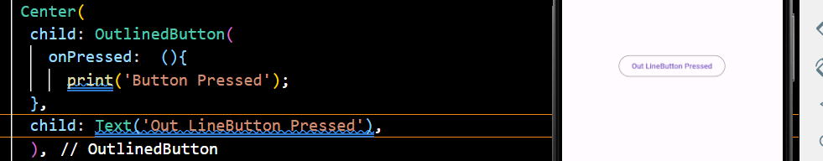

**=====Add Images=====**

**.Lib🡺Assets🡺Images🡺Change Path🡺Go To File🡺pubspec.yaml🡺Change Imag🡺Path**

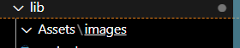



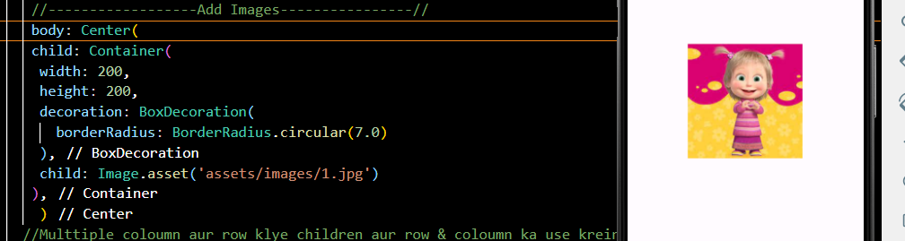

**=====Add Multiple Background Colors====**

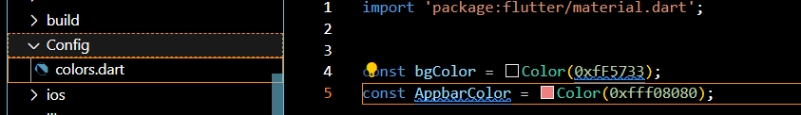

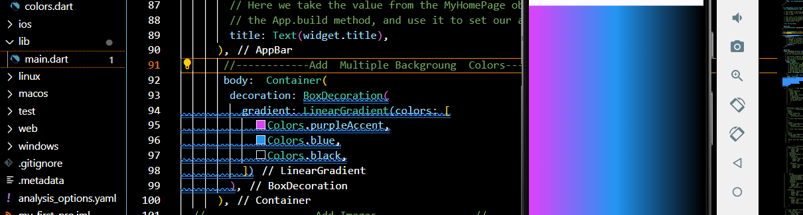

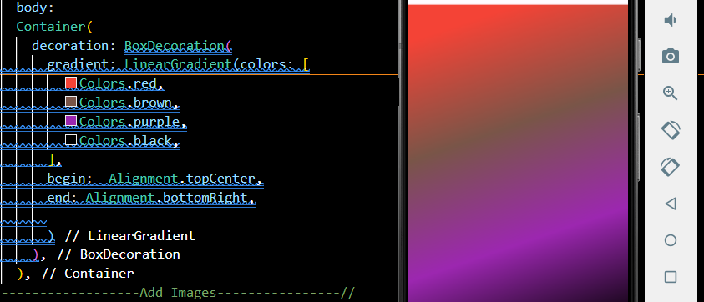

**Multuple Container Add With Images And ScrollView**

**--Vertical Klye 🡺Column Ka use krein gy**

**--HoriZontal klye🡺Rows ka Use krein gy**

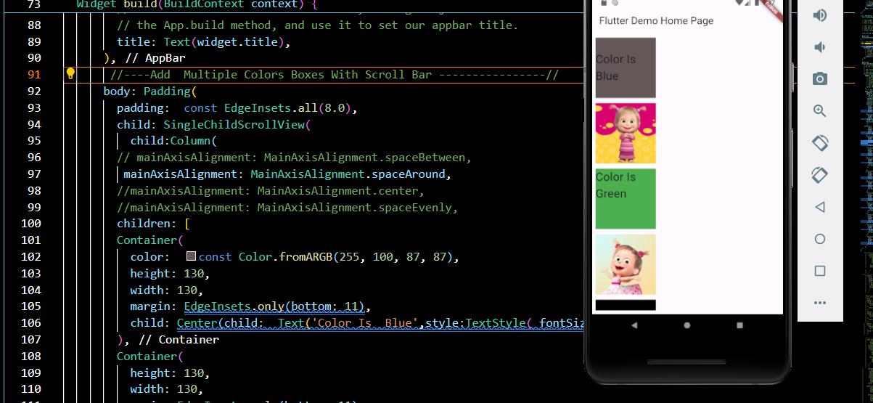

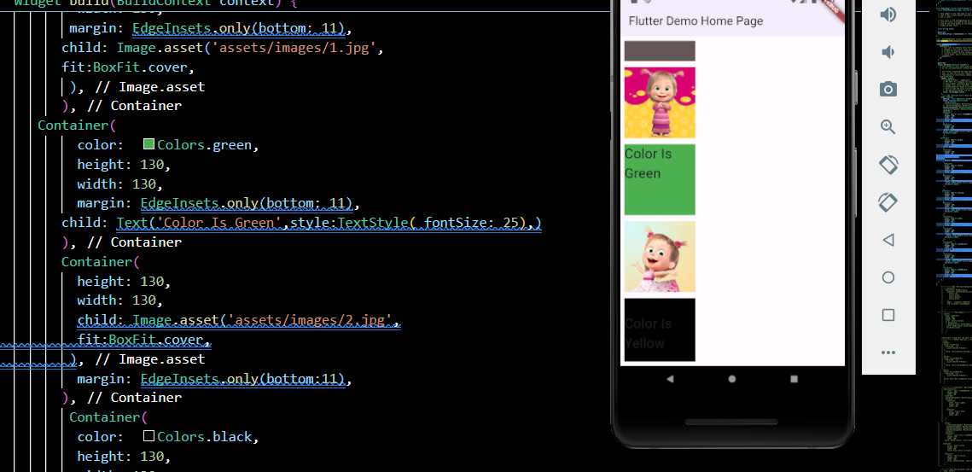

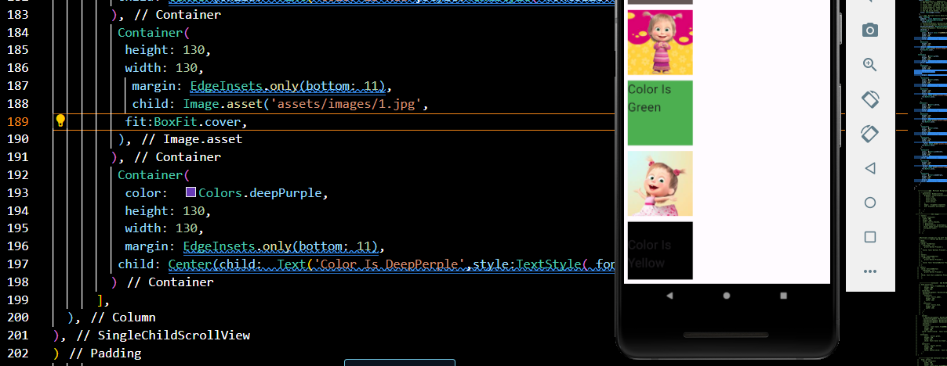

**Scroll Bar HoriZontal**

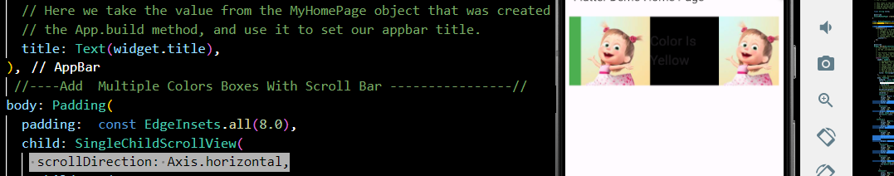

**List View ScrollBar HoriZontal**

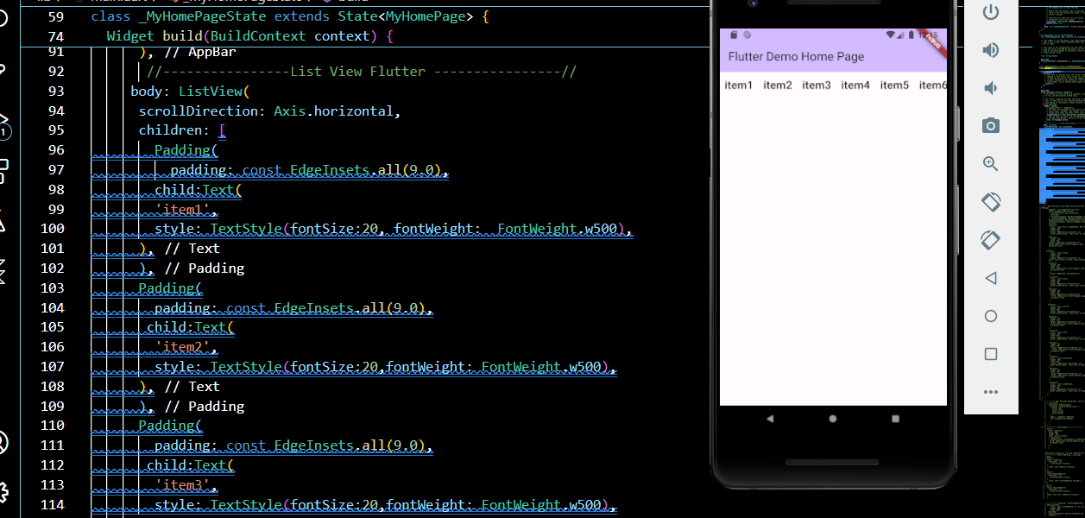

**ListView Scroll Bar Vertical**

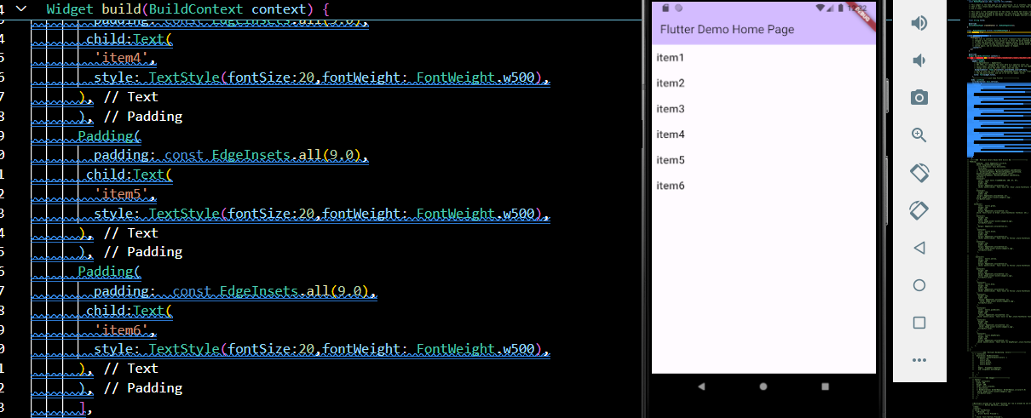

**====VertIcal=====**

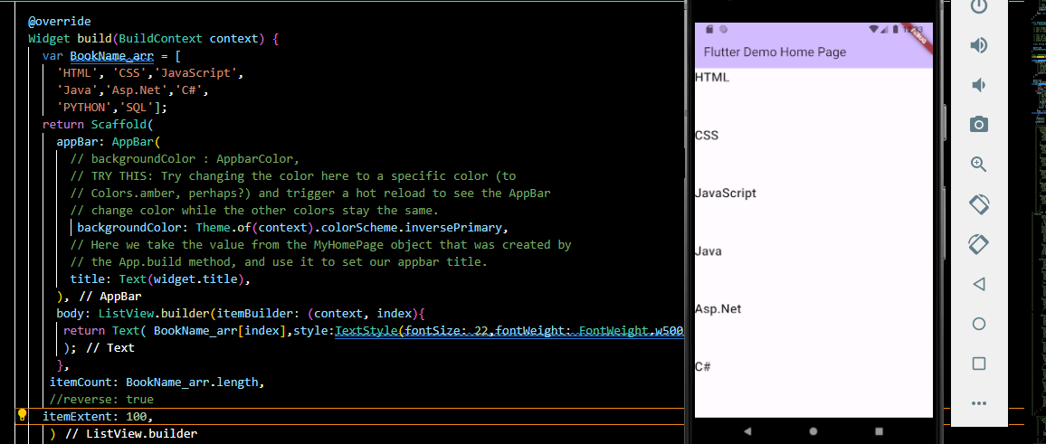

**=====HoriZoOonTal=====**

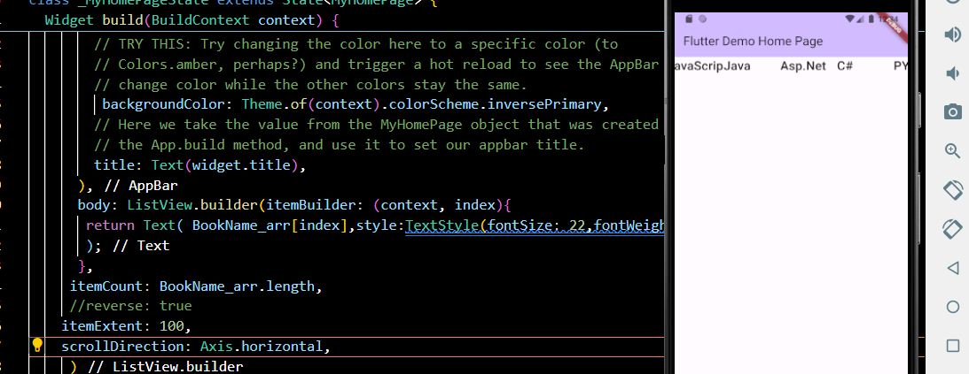

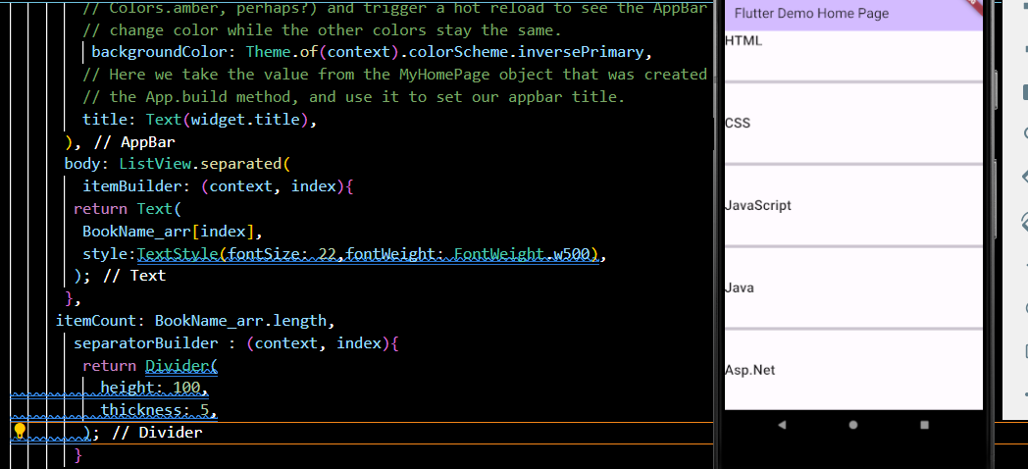

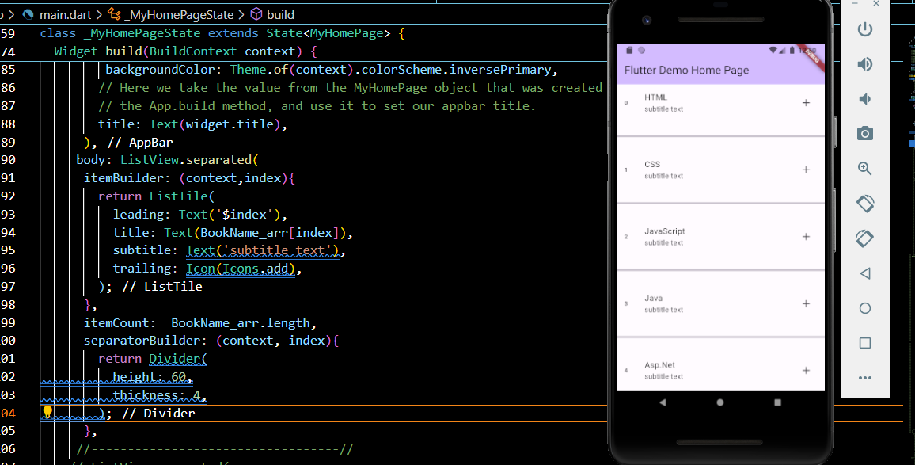

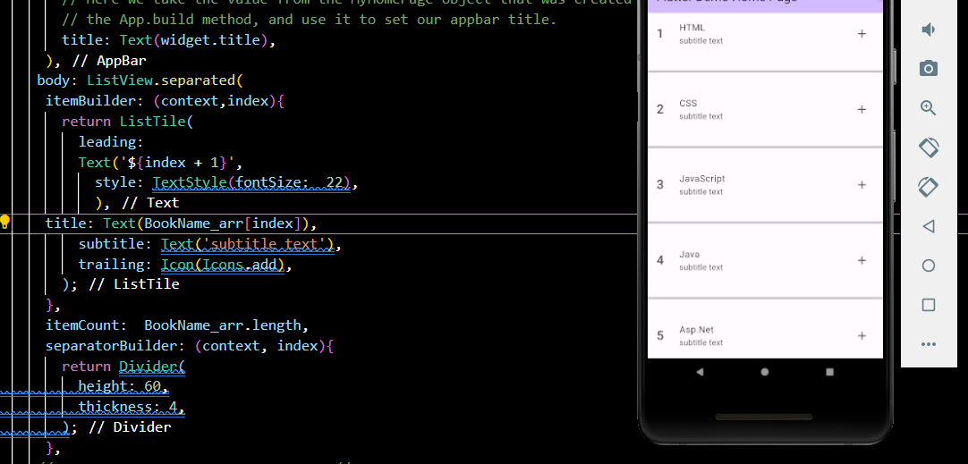

**---Add Images---**

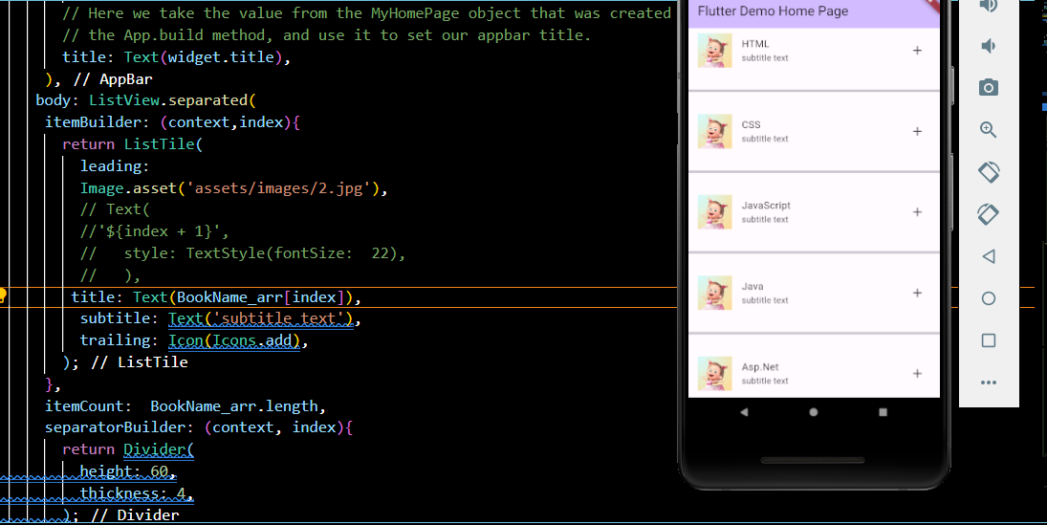

**===List View Using By Dart Flutter==**

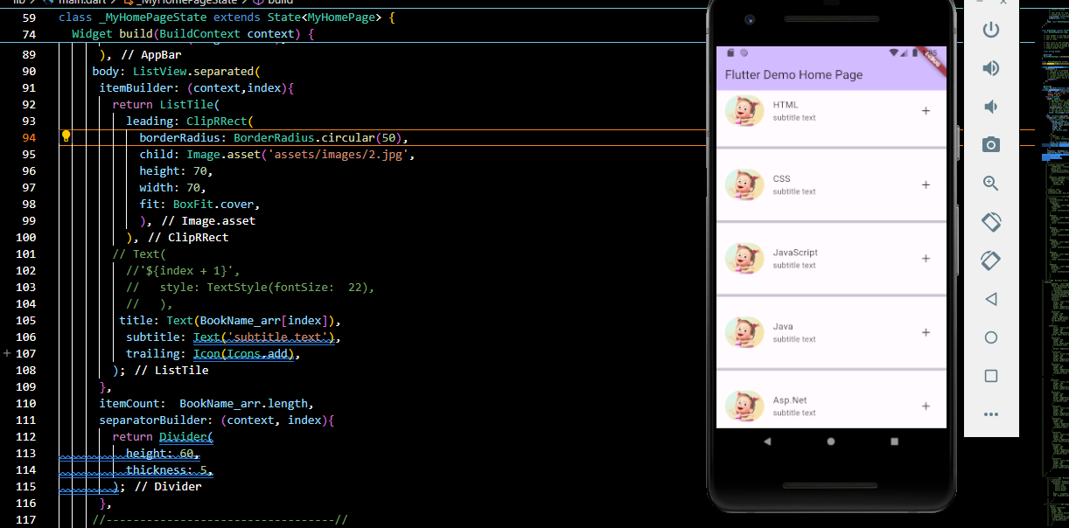

**====MultiPle Images Add====**

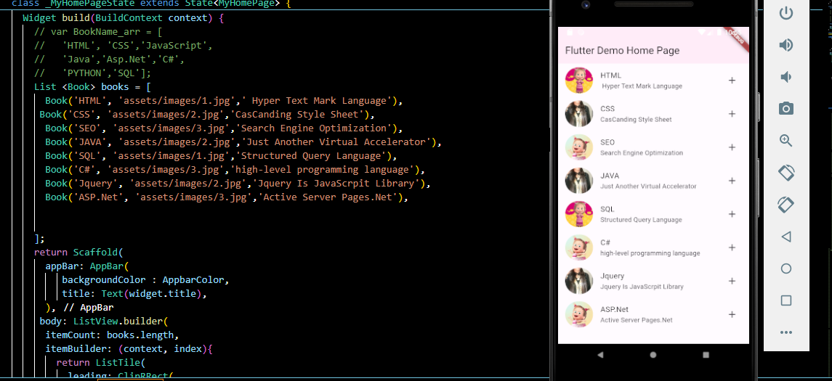

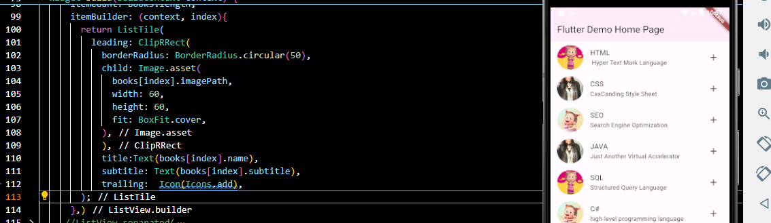

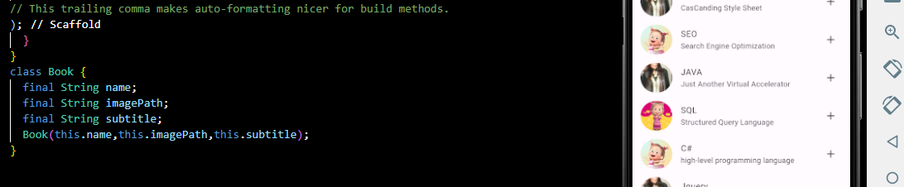

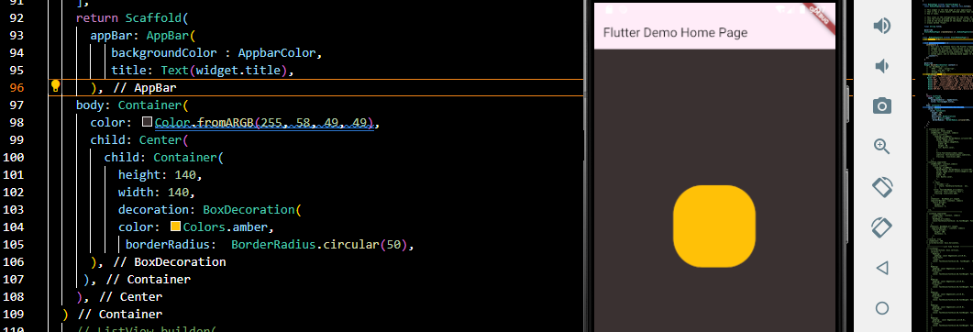

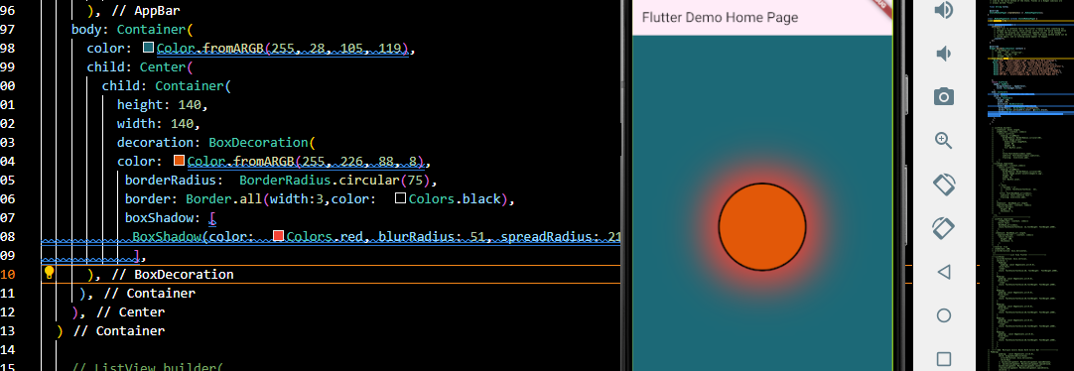

**.BorderRaduis🡺 k Alwa 🡺Shape kii Class Ka bhii kr skhty hain🡺aur ismai just two property ka use kr skhty hain Circle And Traingle**

**.shape: BoxShape.Circle**

**.shape: BoxShape.traingle**

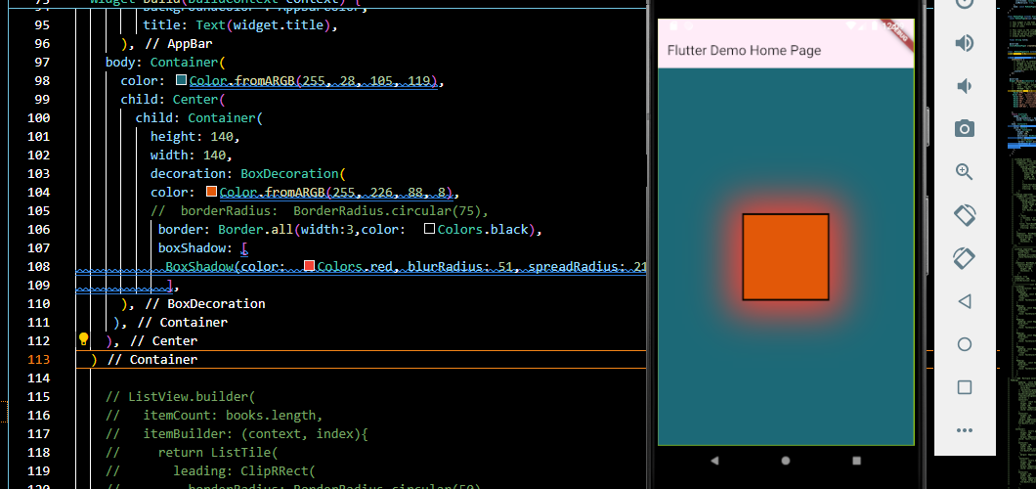

**🡸=Multiple Pages Add=🡺**

**.Main🡺Button ki Class Bna ein gy🡺Button🡺File Ka Url put krein gy🡺Aur Phir Usfile mai ja kr working krein gy**

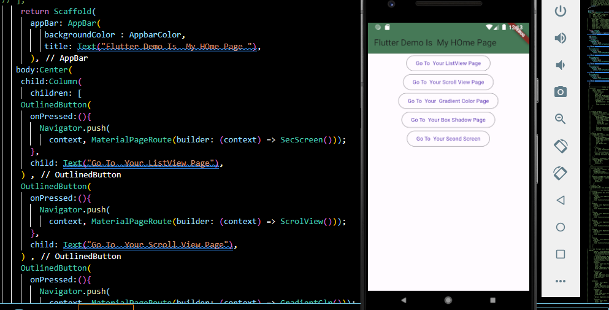

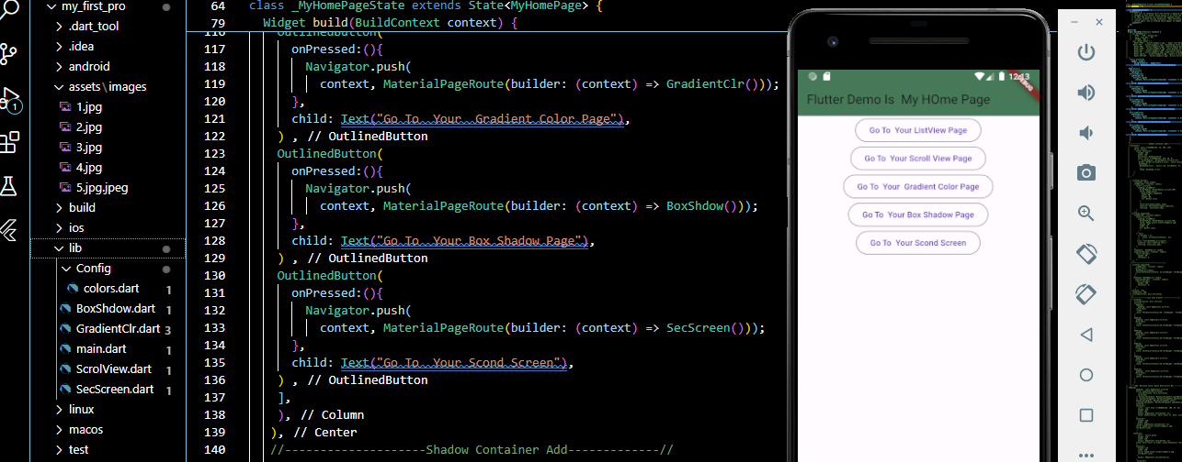

**===This Is mY Second home Screen [List View Page]==**

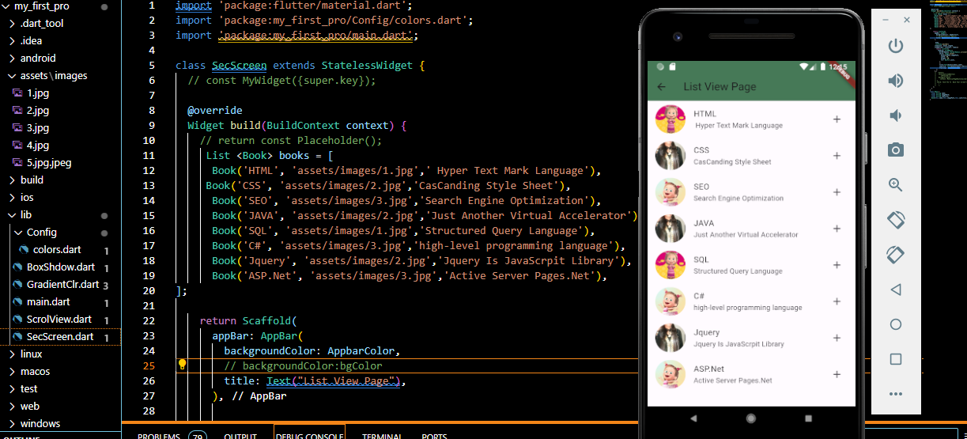

**=======Splash Window======**

**Main.dart🡺File🡺Routing🡺After Home🡺**

 home:  Splash_Win(),

**Create New File🡺Splash_Window🡺**

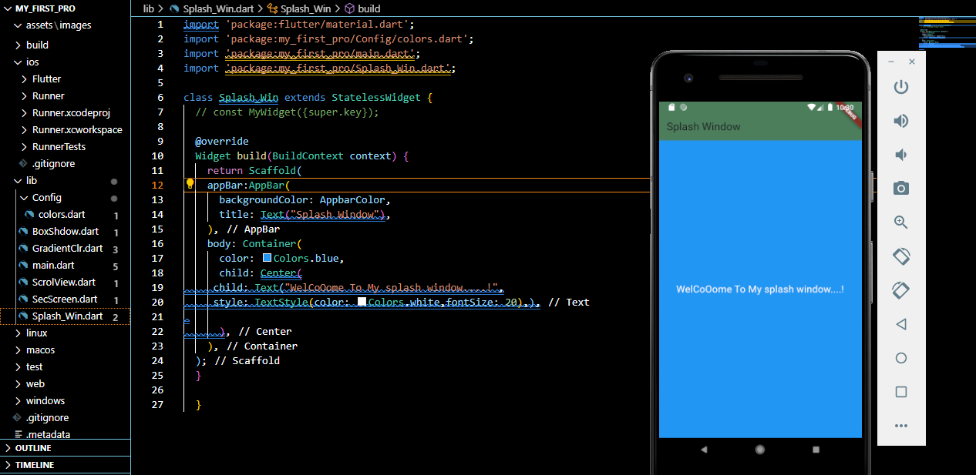

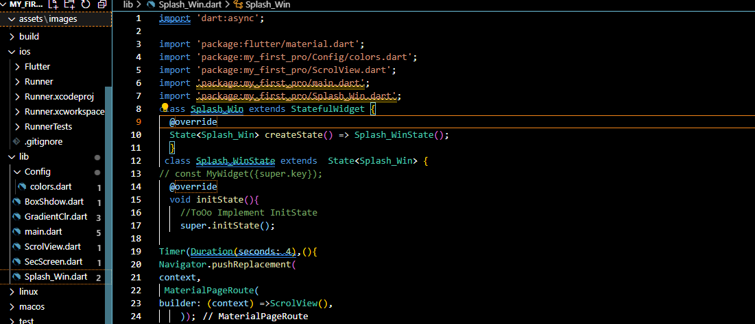

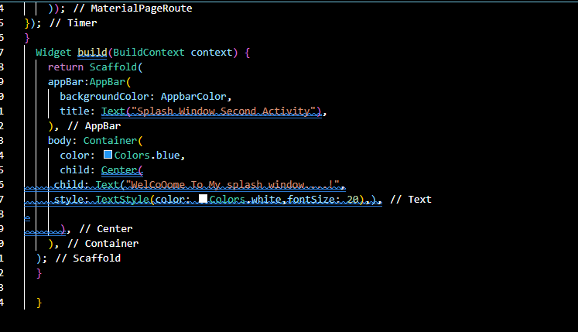

**========== List Wheel Scroll View WitOut Image============**

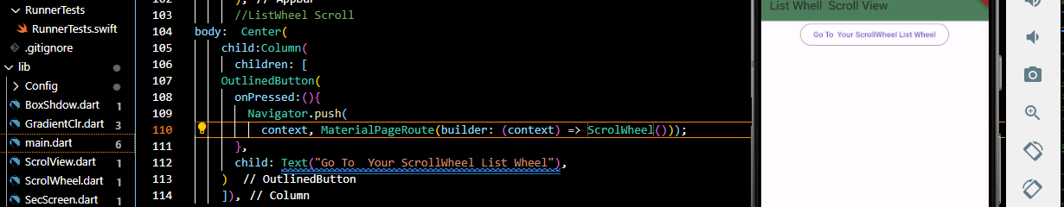

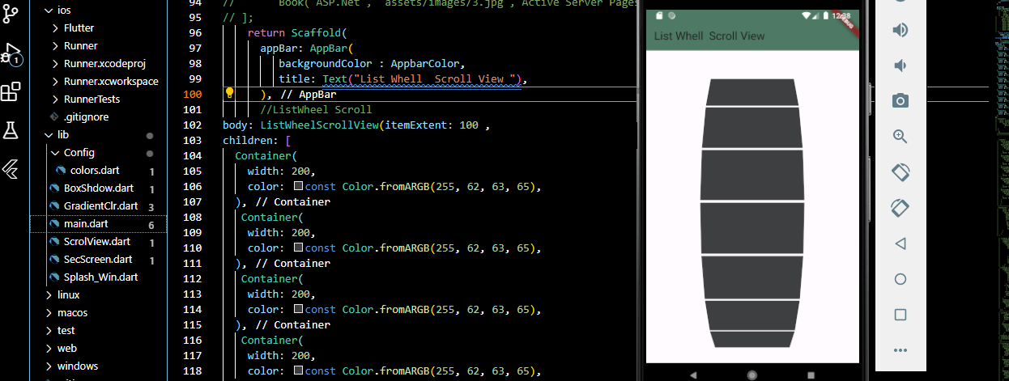

**========== List Wheel Scroll View With Image============**

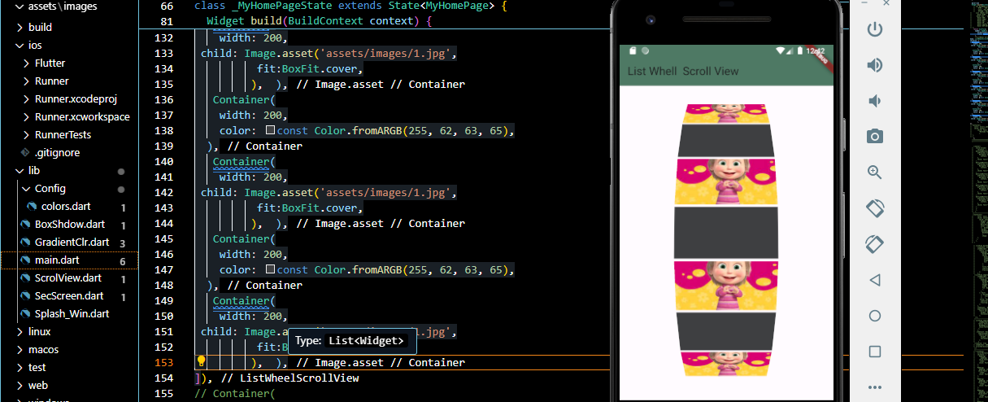

**===== AuthentiCation Login && Register=====**

**------First off All🡺Add Working🡺Splash Window------**

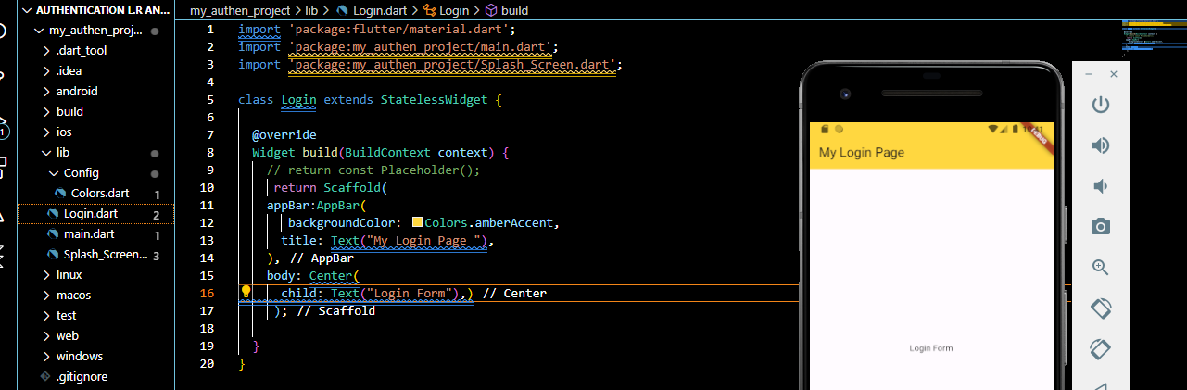

**Text Field🡺 HoriZontal Line Klye Use Kia Jata**

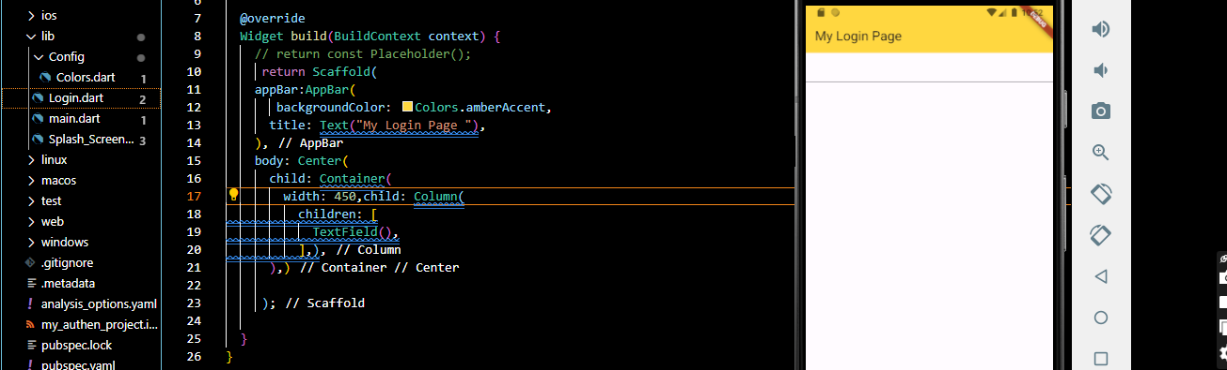

**==Input Field Add==**

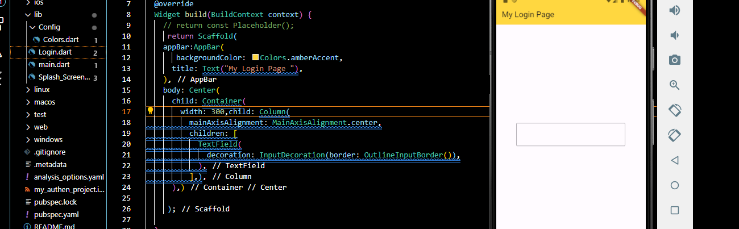

**--------Border Radius Add--------**

 TextField(

              decoration: InputDecoration(border: OutlineInputBorder(borderRadius: BorderRadius.circular(20))),

            ),

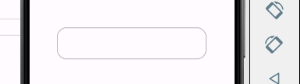

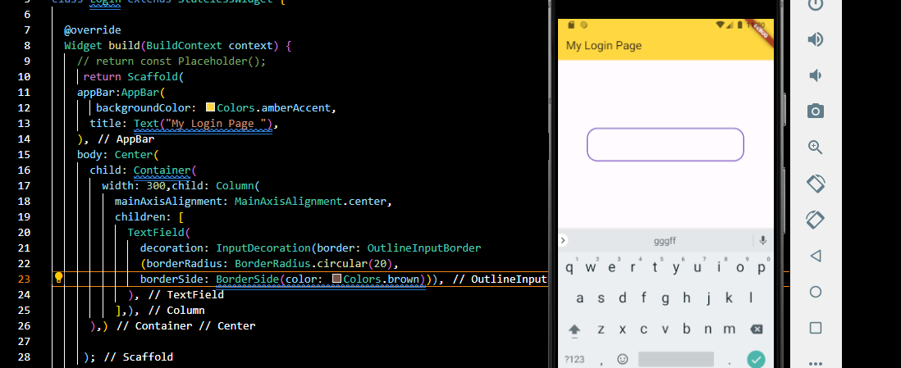

**----There Are Three Types Of Boder------🡪FocusedBorder🡪EnableBorder🡪DisableBorder**

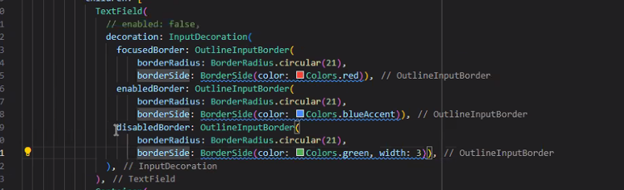

**\*\*\*\*\* Complete Login Form With Splash Window\*\*\*\*\***

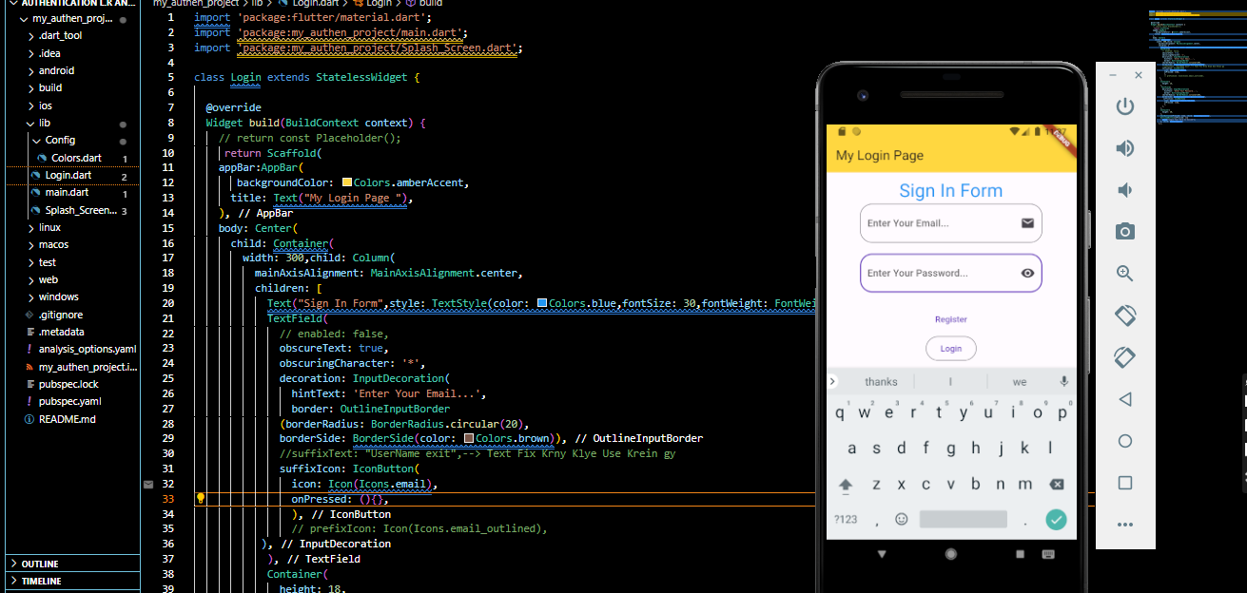

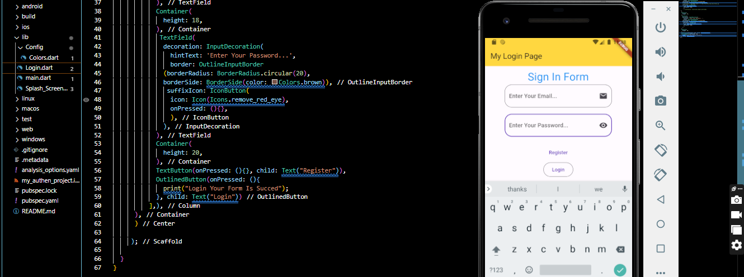

**\*\*\*\*\* Complete Register & Login Form With Splash Window\*\*\*\*\***

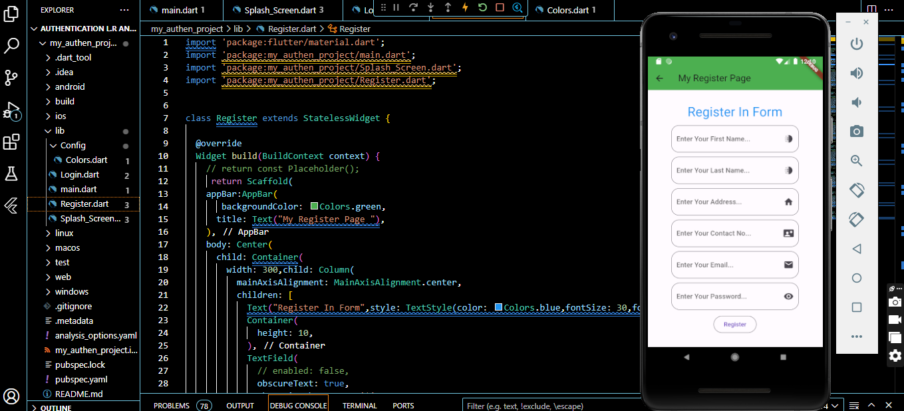

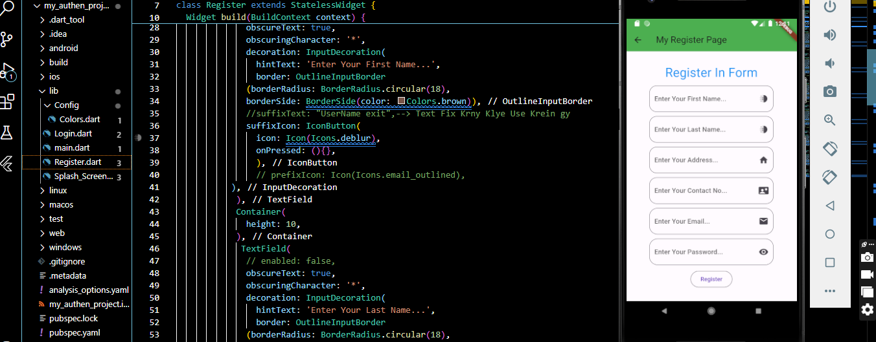

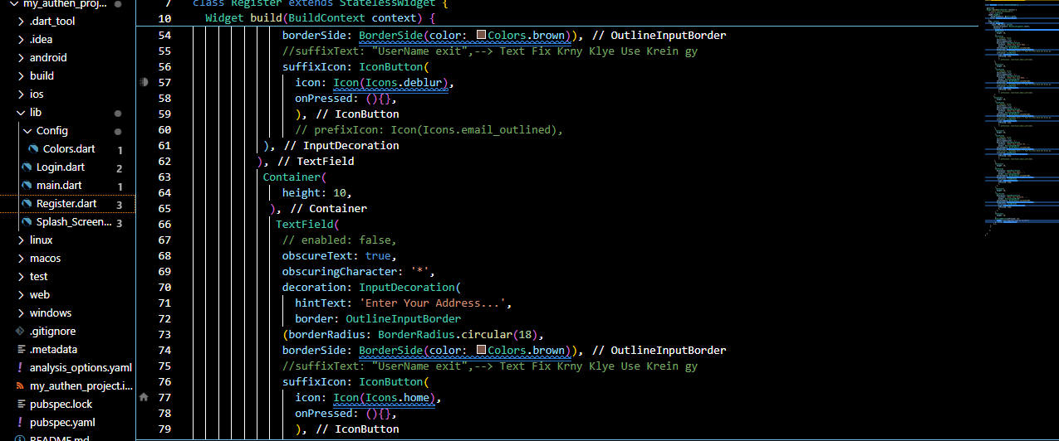

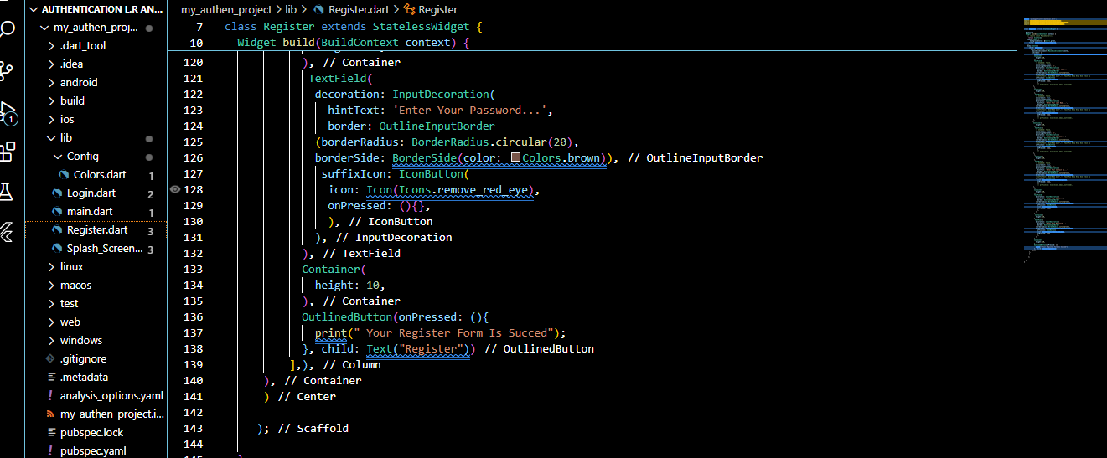

**-------------Text Link Page🡺Use InKwell Method -------------**

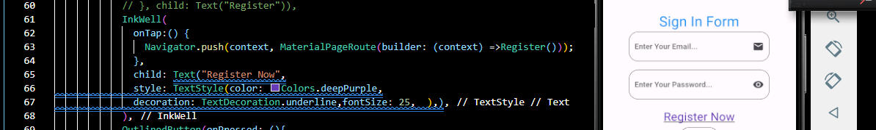

**===Icon Change Your project Method===**

**\*\*\*\*\*\*\*\*\* Andriod Database Connectivity With Using Fire Base\*\*\*\*\*\*\*\*\***

**----------------------STEP BYyY STEP--------------------**

**\*)Open🡺Google 🡺Search FireBase🡺Get Start🡺Add Project🡺Project Name🡪It’s Your Choice🡺Continue🡺Enable Option Off🡺Create🡺Create Project🡺Finshing Up🡺Continue**

**\*)Andriod Option Select🡺Register App🡺Andriod Pkgs Name🡺Go To Folder🡺App🡺File Open🡺Build.graidle🡺Copy Application Id🡺Register App🡺Download🡺Config Json File🡺Next**

**\*)Open App Folder🡺Put file Config Json**

**\*)Open App Folder🡺File🡺Build.Gradle🡺Add Plugins**

**\*)Open Andriod Folder🡺Build.Gradle🡺Add Deffencies**



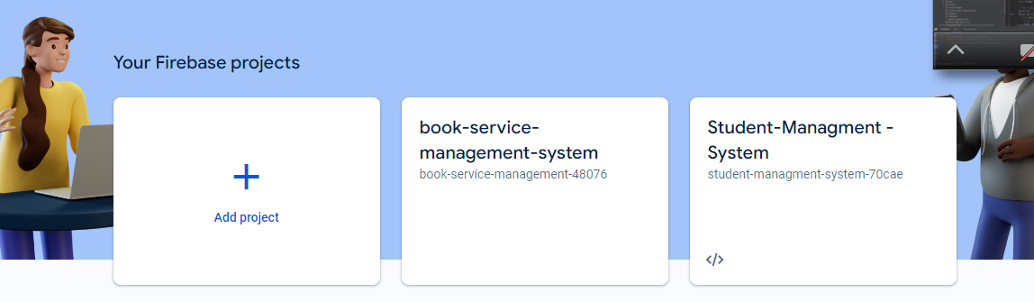

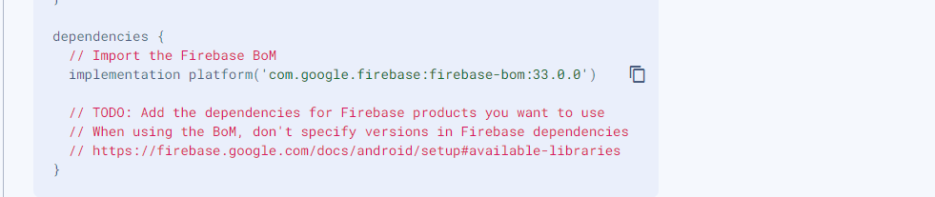

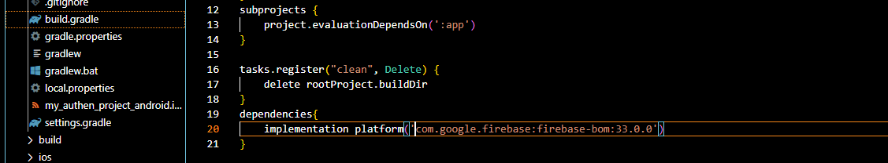

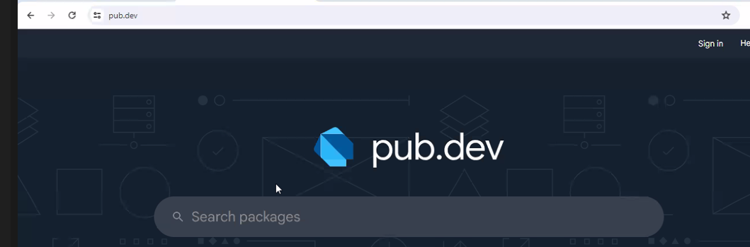



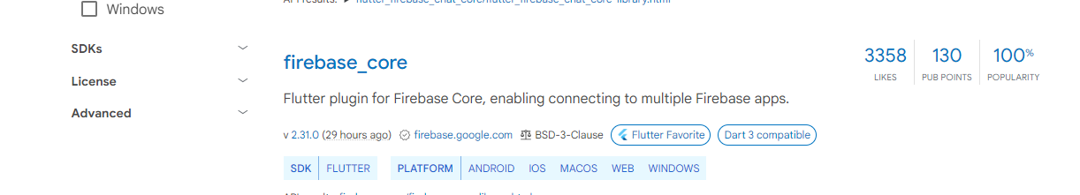

**---------Copy SDK Path & Paste Pubspecy.yaml-------**



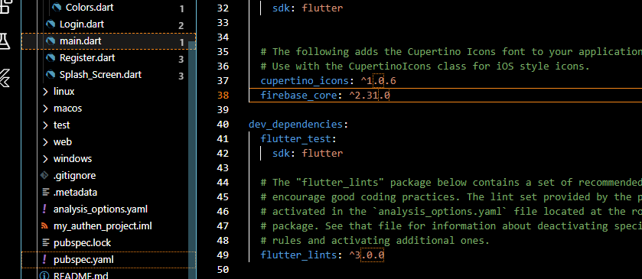



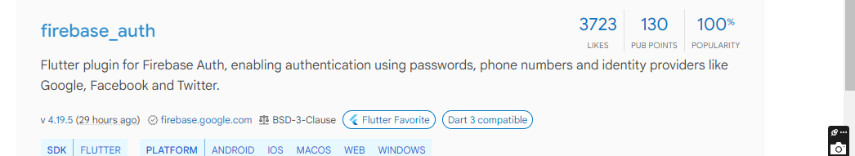

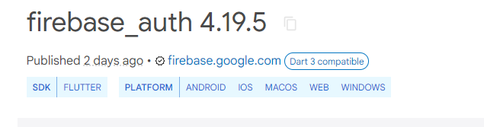

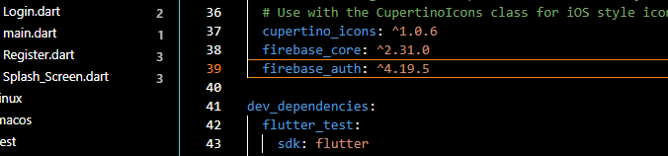**---------FireBase Auth Example Add---------**

**-------Example Copy🡺Past 🡺Main.dart🡺File🡺Main Void🡺Method🡺Paste-----**

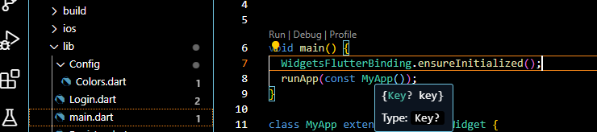

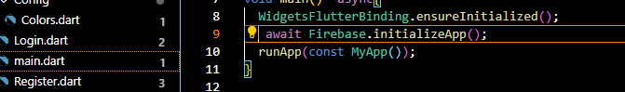

**------Add Sdk Version Add In🡺App🡺build.gradle**

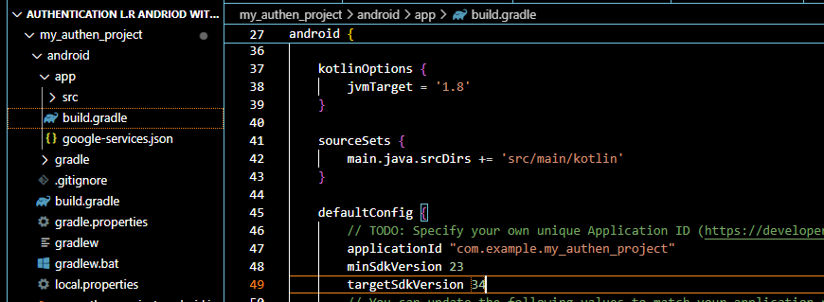

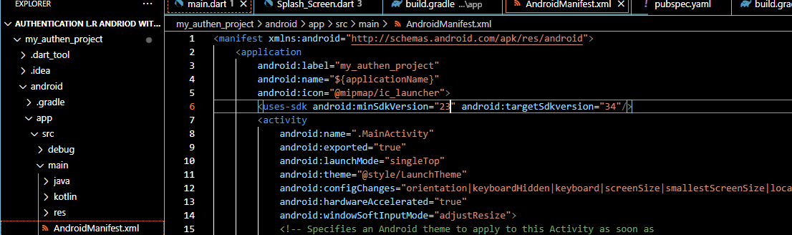

AYESHA KHAN